**WEEK- 1**

**OBJECTIVES**

To help the students in learning the practical use of MS-Word, MS-Excel.

**OUTCOMES**

After completing this, the students would be able to:

Use MS-Word, MS-Excel in real life applications.

**PROBLEMS**

**1# Open a new document and type the following letter.**

July 15, 2020

Chennai

From

VENKATESH. P

Sri Ranga Apartments,

No: 120, II Avenue,

T. Nagar. Chennai-17

To

<<Name>>

<<Address>>

Respected <<Name>>

With the current slowdown in hiring within the ................... I am interested in a project management position in the Rs. 9K range. Thank you!

Venkatesh.

**1[i] Save the document as "Letter.doc."**

•Click FILE > Save, browse a folder, type "Letter" for your document in the File name box, and click Save.

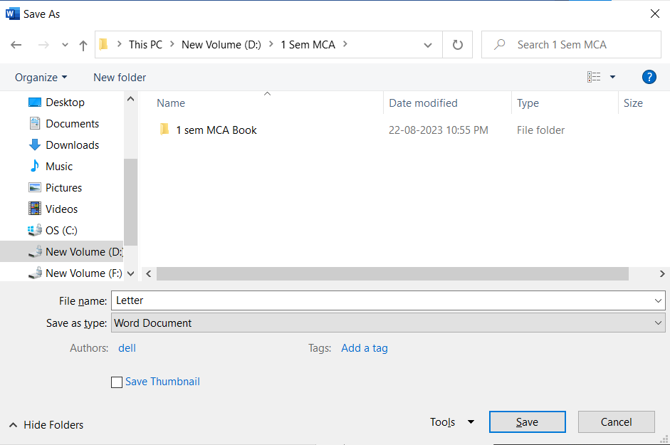

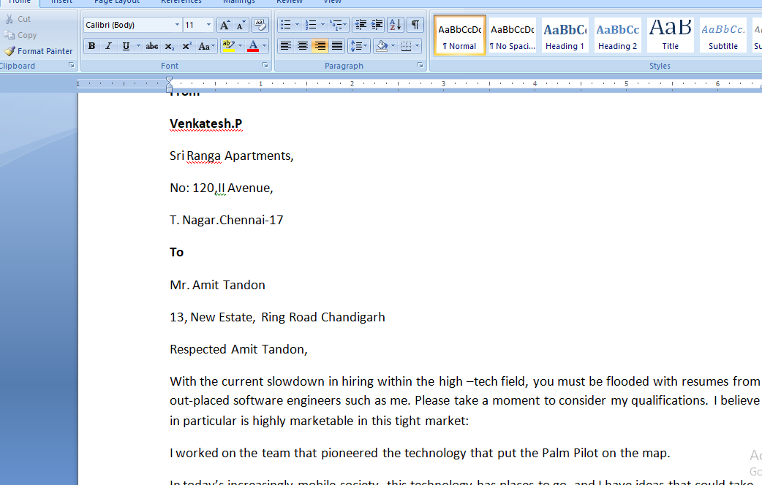

**1[ii] Send the document to 3 recipients using Mail merge.**

**1[v] The Sample Addresses are:**

1. **Mr. Amit Tandon 13, New Estate, Ring Road, Chandigarh**
2. **Mr. Rohit Saluja 15, Karol Bagh, New Delhi**
3. **Ms. Jyoti Parmar Sector 16, New Building, Gurugram**

* In "Mailings" tab. Click on "Select Recipients", select "Type New List"
* Customize columns and enter recipient "Name" and "Address". Save the list.

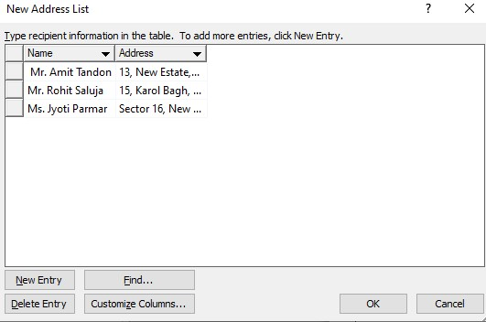

**Step-1:** In the "Mailings" tab. Click on "Start Mail Merge" and select "Letters" **Step-2:** Select "Use the current document".

**Step-3:** Select "Use an existing list" and choose the saved recipient list. Finalize the recipients from Mail Merge Recipients dialog box and click OK.

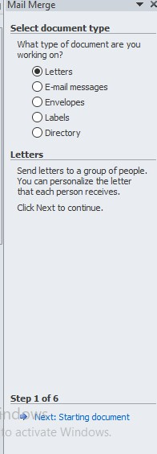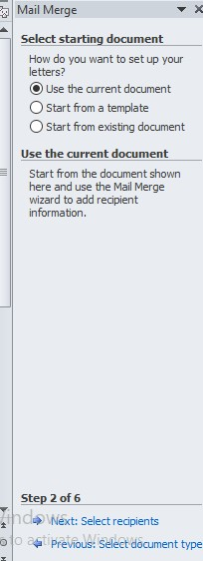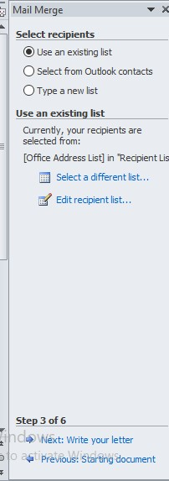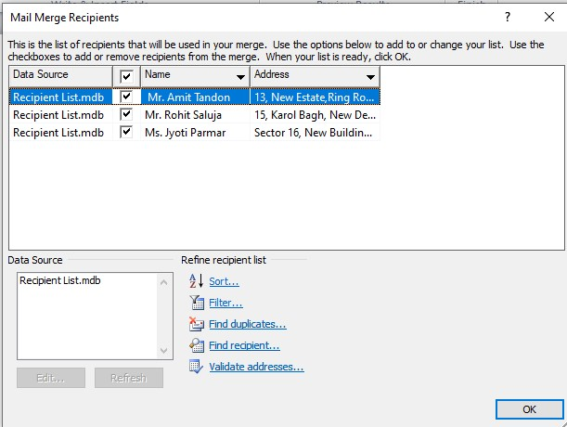

**Step-4:** In "Write your letter" section click "More items". "Insert Merge Field" dialog box appears. From "Database Fields" select location of "Name" and "Address" to be inserted and click "Insert".

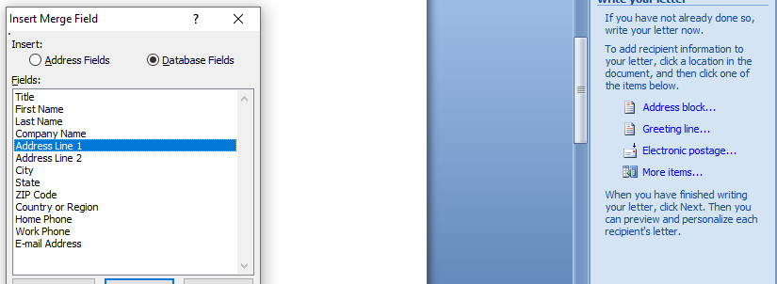

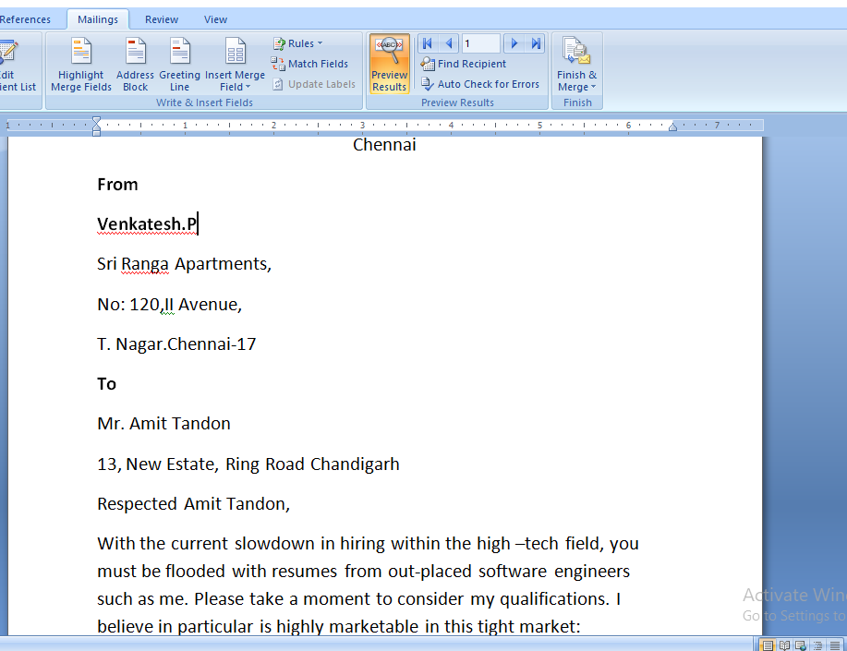

**Step-6:** Lastly, print the letters.

**1[iii] Define a Macro 'Decorate' which makes the text bold, Red in color and italic, font size Assign a shortcut key Alt + Z to this macro.**

* From "File" menu, select "Options" > "Customize ribbon" > "Developer"

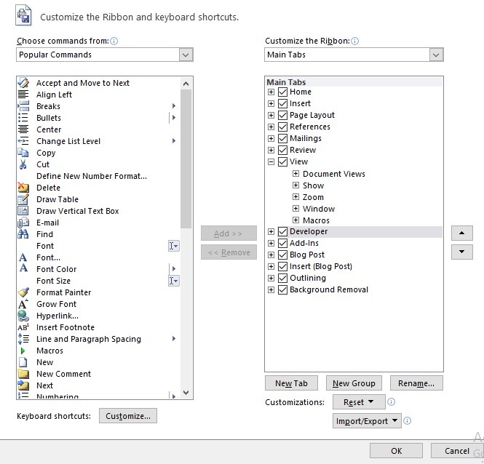

* From "View" menu, select "Macros"
* Choose "Create" and write the following code in VBA and close.

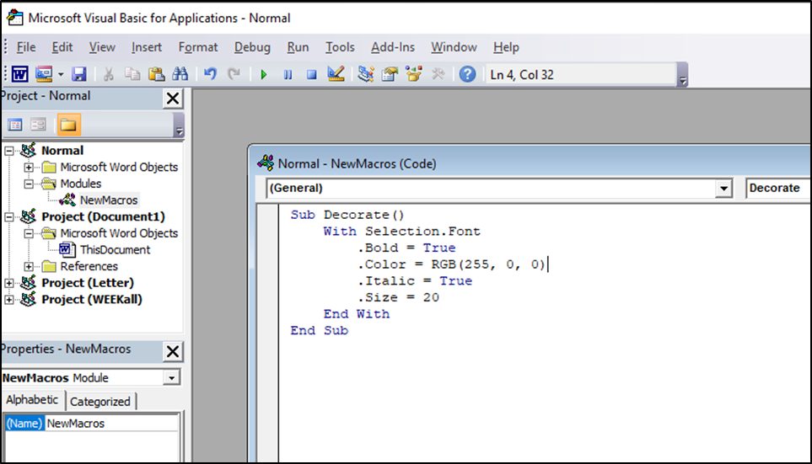

* From "File" menu, select "Options" > "Customize".
* "Customize Keyboard" dialog box appears.
* Select "Macros" option in "Categories" and select macro name "Decorate"
* Enter shortcut keys as "Alt+Z"

•

Click

"

Assign

"

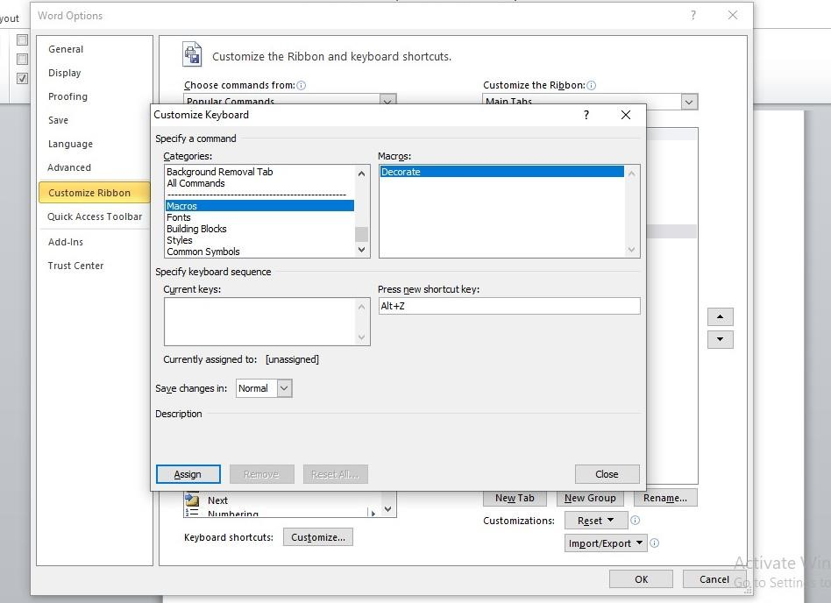

* Now select the text, and click Alt + Z to apply Decorate Macro.

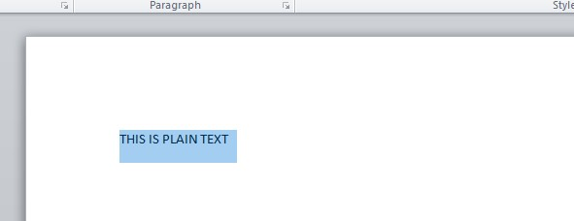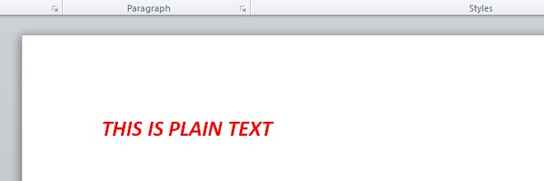

**1[iv] Close the document.**

**Click on the “File” and select close**

**Write Resume in given format**

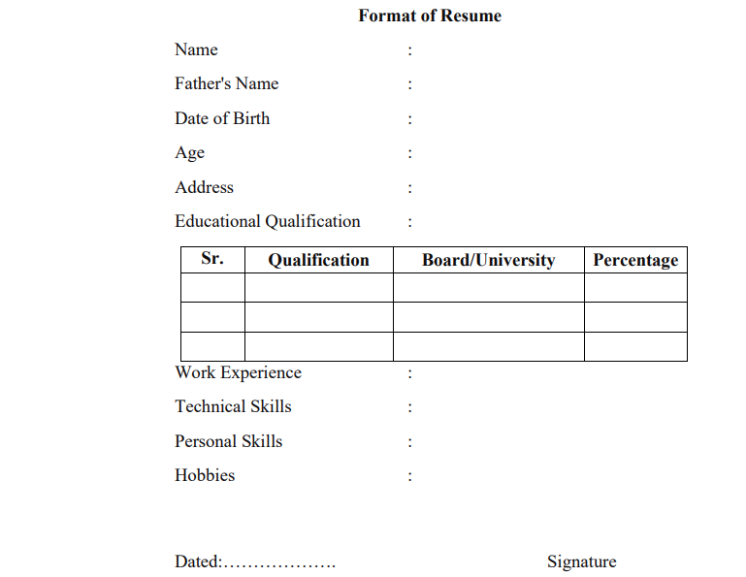

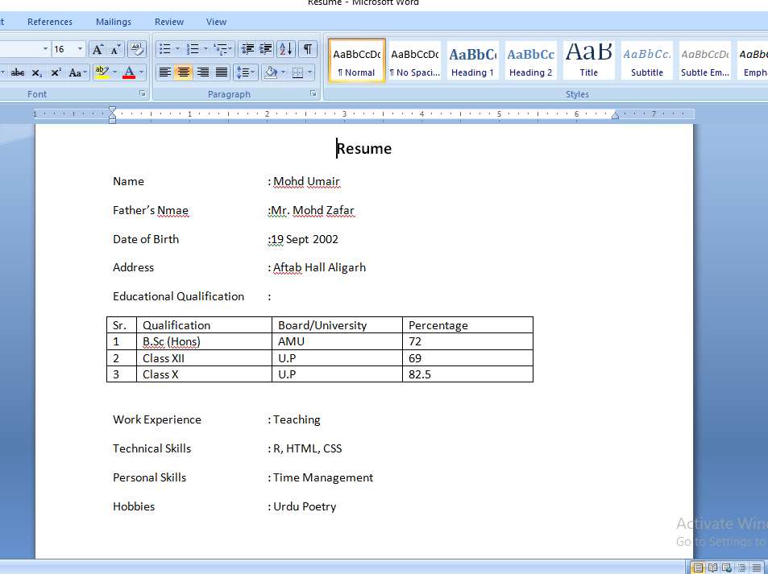

**2# Create a table in word as shown below:**

|  |  |  |  |  |
| --- | --- | --- | --- | --- |
| Roll No | Name | Marks in Physics | Marks in Chemistry | Total Marks |
| 1 | Sakshi | 80 | 70 |  |
| 2 | Rohit | 70 | 80 |  |
| 3 | Amit | 60 | 50 |  |
| 4 | Rakesh | 40 | 60 |  |
| 5 | Komal | 30 | 70 |  |
| 6 | Garima | 80 | 80 |  |

**2[i] In the total marks' column, entries should be calculated using formulas and it is the sum of marks in physics and marks in chemistry.**

* Click on the cell where the total to be displayed.
* Go to the "Table Tools" and then select the "Layout" tab. In the "Data" group, click the "Formula" option.
* In the "Formula" dialog box, set up the formula to calculate the total marks. Since the total marks are the sum of physics and chemistry marks, use formula "=SUM(LEFT)" and click "OK" to apply it.

|  |  |  |  |  |
| --- | --- | --- | --- | --- |
| Roll No | Name | Marks in Physics | Marks in Chemistry | Total Marks |
| 1 | Sakshi | 80 | 70 | 150 |
| 2 | Rohit | 70 | 80 | 150 |
| 3 | Amit | 60 | 50 | 110 |
| 4 | Rakesh | 40 | 60 | 100 |
| 5 | Komal | 30 | 70 | 100 |
| 6 | Garima | 80 | 80 | 160 |

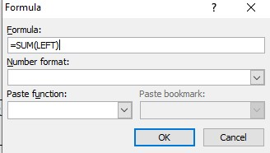

**2[ii] Insert a new row at the end of the table and also find grand total using formula.**

* Right-click on the last row, go to "Insert," and choose "Insert Rows Below".
* Click on the cell where the grand total to be displayed.
* Go to the "Table Tools" and then select the "Layout" tab. In the "Data" group, click the "Formula" option.
* In the "Formula" dialog box, set up the formula to calculate the total marks. Since the total marks are the sum of physics and chemistry marks, use formula "=SUM(ABOVE)" and click "OK" to apply it.

|  |  |  |  |  |
| --- | --- | --- | --- | --- |
| Roll No | Name | Marks in Physics | Marks in Chemistry | Total Marks |
| 1 | Sakshi | 80 | 70 | 150 |
| 2 | Rohit | 70 | 80 | 150 |
| 3 | Amit | 60 | 50 | 110 |
| 4 | Rakesh | 40 | 60 | 100 |
| 5 | Komal | 30 | 70 | 100 |
| 6 | Garima | 80 | 80 | 160 |
|  |  |  |  | 770 |

**2[iii] Sort the table based on total marks.**

* Go to the "Table Tools" and then select the "Layout" tab. In the "Data" group, click the "Sort" option.

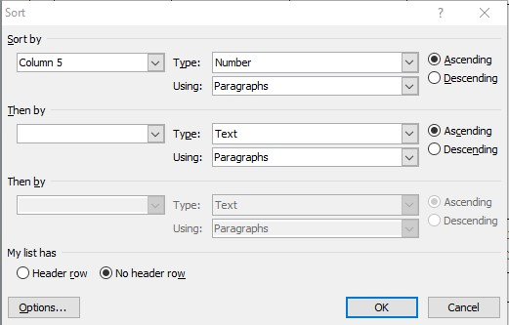

|  |  |  |  |  |
| --- | --- | --- | --- | --- |
| Roll No | Name | Marks in Physics | Marks in Chemistry | Total Marks |
| 4 | Rakesh | 40 | 60 | 100 |
| 5 | Komal | 30 | 70 | 100 |
| 3 | Amit | 60 | 50 | 110 |
| 1 | Sakshi | 80 | 70 | 150 |
| 2 | Rohit | 70 | 80 | 150 |
| 6 | Garima | 80 | 80 | 160 |
|  |  |  |  | 770 |

**2[iv] The data and heading should be centre aligned.**

* Select the table cells. Go to the "Home" tab. In the "Paragraph" group, click Center align icon.

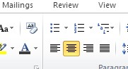

|  |  |  |  |  |
| --- | --- | --- | --- | --- |
| Roll No | Name | Marks in Physics | Marks in Chemistry | Total  Marks |
| 4 | Rakesh | 40 | 60 | 100 |
| 5 | Komal | 30 | 70 | 100 |
| 3 | Amit | 60 | 50 | 110 |
| 1 | Sakshi | 80 | 70 | 150 |
| 2 | Rohit | 70 | 80 | 150 |
| 6 | Garima | 80 | 80 | 160 |
|  |  |  |  | 770 |

**2[v] Heading should be in bold and underlined.**

* Select heading row.
* Right-click and select icon for bold text.
* Select  icon for underlined text.

|  |  |  |  |  |
| --- | --- | --- | --- | --- |
| **Roll No** | **Name** | **Marks inPhysics** | **Marks inChemistry** | **Total**  **Marks** |
| 4 | Rakesh | 40 | 60 | 100 |
| 5 | Komal | 30 | 70 | 100 |
| 3 | Amit | 60 | 50 | 110 |
| 1 | Sakshi | 80 | 70 | 150 |
| 2 | Rohit | 70 | 80 | 150 |
| 6 | Garima | 80 | 80 | 160 |
|  |  |  |  | 770 |

**3# Using a spreadsheet package you have studied, construct T Morongo's pay slip for December 2016 following the instructions below. Insert a custom footer with your name, subject, course, exam/Test &question number. Save it as Salary advice.**

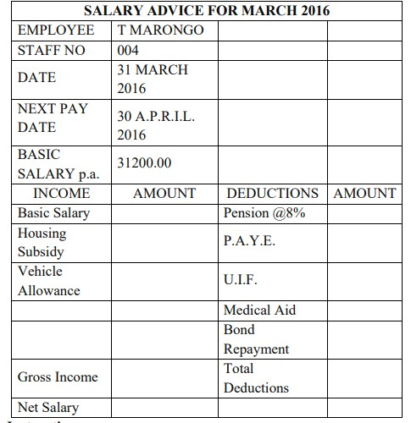

**Insert a Custom Footer:**

* Go to the "Insert" tab in Excel. Click on the "Footer & Header" button.
* In the "Footer" section, input name, subject, course, exam/test detail,etc

**Save the Document:**

* Go to the "File" menu. Select "Save As."
* Choose a location to save the file and enter file name "SalaryAdvice".Click "Save".

**3[i] Housing Subsidy 6000.00 per year. [** i.e. 500.00 per month.] **3[ii] Car Allowance 100.00 per month.**

**3[iii] Pension 8% on Basic Salary.** [=B8*8/100 i.e. 2496]

**3[iv] PAYE 636.83**

**3[v] Medical Aid 70.00**

**3[vi] U.I.F. 1% on Basic Salary + Housing Subsidy** [=(B8+B9)/100 i.e. 317] **3[vii] Bond Repayment 630.00**

**3[viii] Calculate Net Salary.**

Gross Income [=SUM(B8:B10) i.e. 31800]

Total Deductions [=SUM(D8:D12) i.e. 4149.83] Net Salary [=(B13-D13) i.e. 27650.17]

**3[ix] Format all figures to two decimal places and insert ₹ currency symbol.** •Select the cells. Right-click on the selected cells and choose "Format Cells."

* select the "Number" category.In the "Decimal places" field, enter "2" to format the numbers to two decimal places.
* In the "Symbol" section, select "Currency" from the dropdown and choose "₹ Indian Rupee" as the currency symbol. Click OK

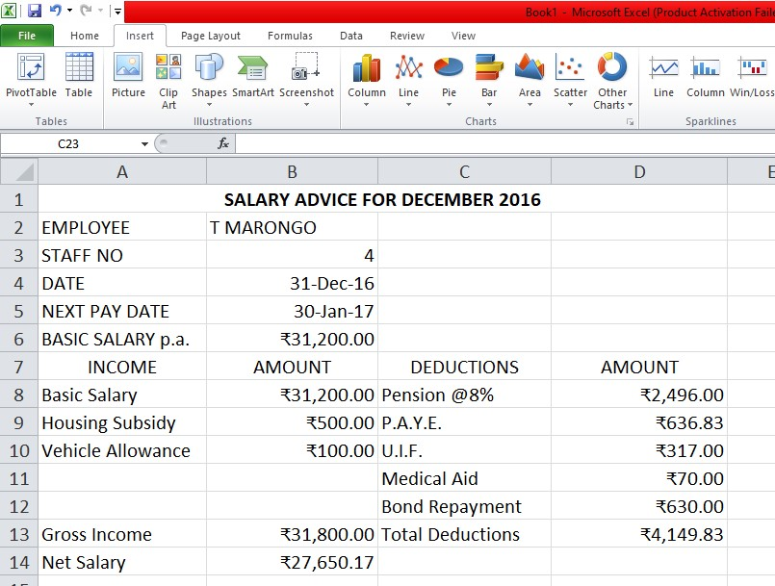

**3[x] Insert a custom footer with your name, subject, and question number.**

**Save it as salary advice2.**

Insert a Custom Footer:

* Go to the "Insert" tab in Excel. Click on the "Footer & Header" button.
* In the "Footer" section, input name, subject and question number.

Save the Document:

* Go to the "File" menu. Select "Save As."
* Choose a location to save the file and enter file name "SalaryAdvice2".Click "Save".

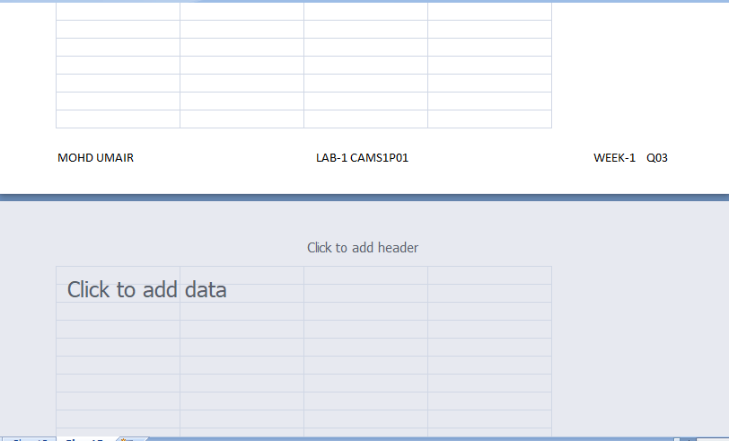

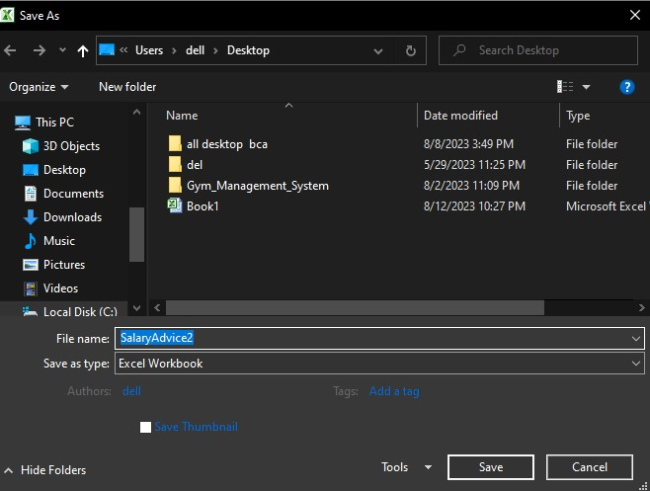

**4# Use a new workbook & construct a worksheet with the data given & save it as LYONS.**

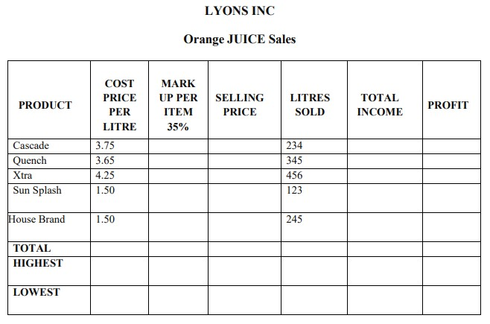

* Go to the "File" menu. Select "Save As."
* Choose a location to save the file and enter file name "LYONS".Click "Save".

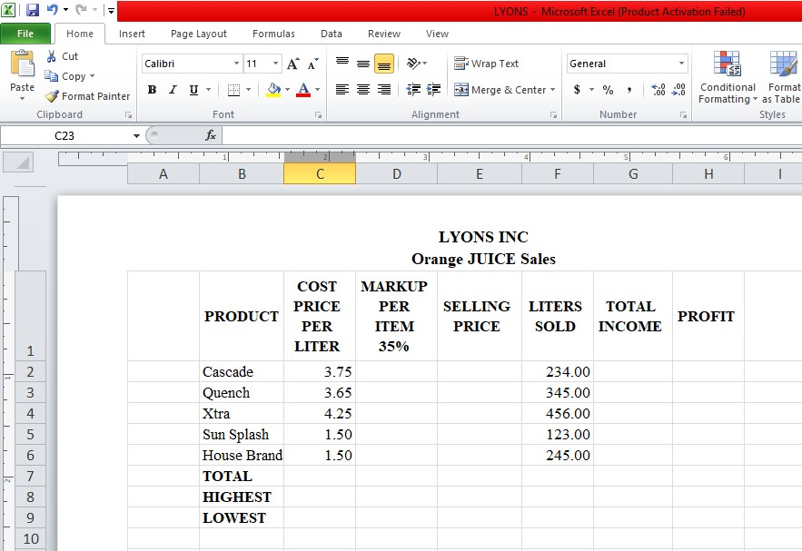

**4[i] The MARKUP % (35%) must be inserted in a separate cell under the heading. USE IT as an absolute cell reference in the formula to calculate the mark up per item.**

**4[ii] Calculate the mark up for each item.**

* Using D2 as an absolute cell reference, enter value 35%.
* Markup = Cost price/Litre x 35%
* Use formula [=C3*$D$2] in D3. Press Enter.
* Drag the + cursor down till D7.The mark up for each item is calculated.

**4[iii] Calculate the selling price for each item.** •Selling price= Cost price/Litre + Mark up

* Use formula [=$C3+$D3] in E3. Press Enter.
* Drag the + cursor down till E7.The selling price for each item is calculated.

**4[iv] Calculate the Total Income for each item.** •Total income= Litres sold x Selling Price

* Use formula [=$E3*$F3] in G3. Press Enter.
* Drag the + cursor down till G7.The total income for each item is calculated.

**4[v] Calculate the profit for each item.**

* Profit = Total income – (Cost price/Litre x Litres sold) •Use formula [=$G3-($C3*$F3)] in H3. Press Enter.
* Drag the + cursor down till H7.The profit for each item is calculated.

**4[vi] Format the column LITRES SOLD to display the number of litres as integers. The rest of the worksheet must be formatted to display two decimals.**

* Select the cells of LITRE SOLD column. Right-click on the selected cells and choose "Format Cells."
* Select the "Number" category. In the "Decimal places" field, enter "0" [For others select "2" to format the numbers to two decimal places.] •Click OK

**4[vii] Use statistical functions to calculate the: [for Selling Price column up to Profit Column] a}AVERAGE**

* Use formula [=AVERAGE(E3:E7)] in E11. Press Enter.
* Drag the + cursor to the right till H11 to calculate average for the columns. **b}HIGHEST (MAX.)**
* Use formula [=MAX(E3:E7)] in E9. Press Enter.
* Drag the + cursor to the right till H9 to calculate average for the columns. **c} LOWEST (MIN).**
* Use formula [=MIN(E3:E7)] in E10. Press Enter.
* Drag the + cursor to the right till H10 to calculate average for the columns.

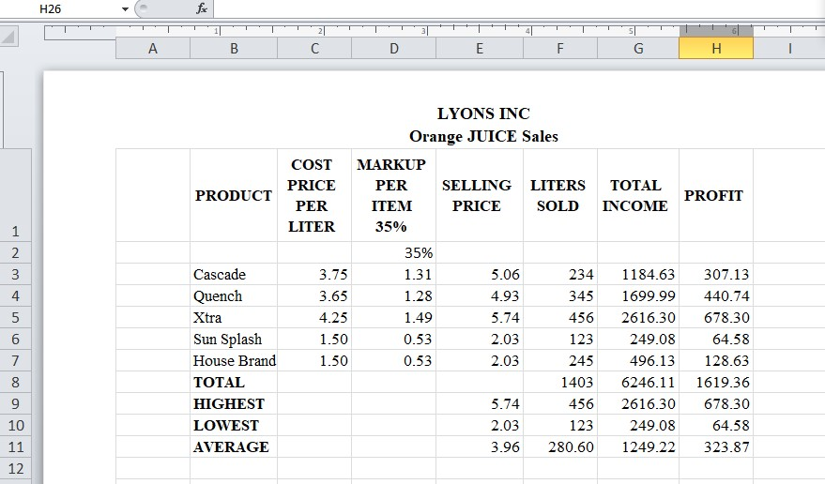

**4[viii] Show all formulas you have used in a new sheet. Adjust the column width so that the formulae are displayed in full and the sheets fits into one side of A4 landscape format and save it as formulas.**

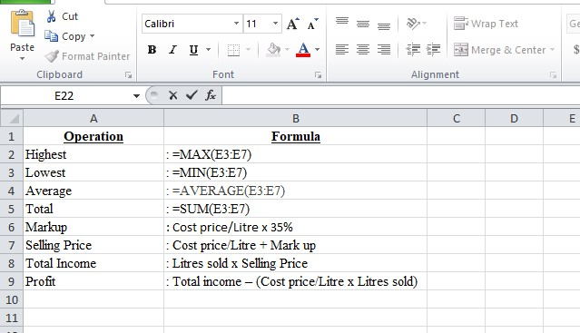

**Steps to fit sheet in A4 Landscape Format:**

* Go to the "Page Layout" tab.
* Click on the "Size" choose A4 option.
* Set "Orientation" to Landscape

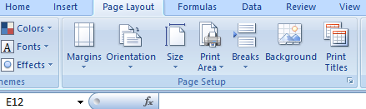

* Go to the "File" menu. Select "Save As."
* Choose a location to save and enter file name "Formulas".Click "Save".

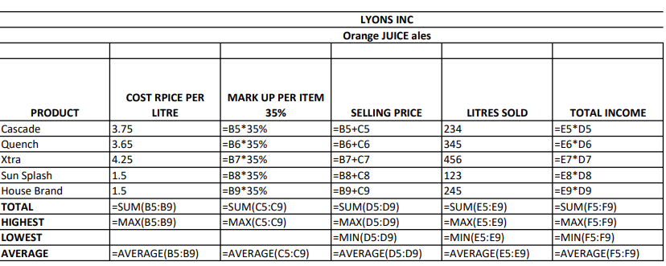

**4[ix] Under the worksheet Create a pie chart titled PRODUCT COST PER UNIT for Product & Cost price per Litre columns. Data labels indicating percentages should be displayed.**

* Select PRODUCT and COST PRICE PER LITRE column cells with data. •From "Insert" menu. Select Pie Chart.

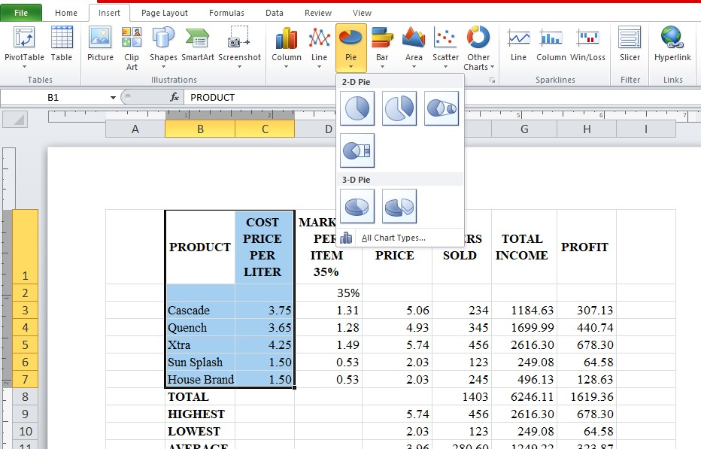

* For data labels, right-click and select "Add Data Labels". In "Format Data Labels" dialog box choose "Percentage".

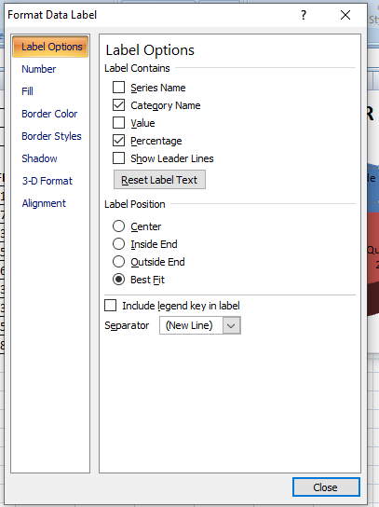

**4[x] Put borders neatly on the on the work sheet & save it as LYONS2.**

* Select all the cells in the worksheet around which border is to be placed.
* Go to the "Insert" menu. Select Border icon "", choose border type.
* Go to the "File" menu. Select "Save As."
* Choose a location to save and enter file name "LYONS2".Click "Save".

